**TEST CASES OF SMART CAMPUS SYSTEM**

**Test cases for Smart Campus Management system**

Test cases for Login to the system

|  |  |
| --- | --- |
| Project Name: | Smart campus Management system |
| Date created and Executed: | 16/03/2025 |
| Created and Executed By: | Fathima Nuzrath Nawfer |
| Test case ID | 01 |
| Test scenario | Login to the system |
| Test Case | Valid username and password |
| Pre-Condition | use the username as Admin and password as admin123 and login |
| Expected result | Successful login |
| Post condition | It will direct you to dashboard |
| Actual result |  |
| Status  (success  /Failure) | Success |

|  |  |
| --- | --- |
| Project Name: | Smart campus Management system |
| Date created and Executed: | 16/03/2025 |
| Created and Executed By: | Fathima Nuzrath Nawfer |
| Test case ID | 02 |
| Test scenario | Login to the system |
| Test Case | Input value |
| Pre-Condition | Not input username value and password value click onto login button |
| Expected result | This field required to be filled |
| Post condition | Alert message saying please fill out this field |
| Actual result |  |
| Status  (success  /Failure) | Success |

|  |  |
| --- | --- |
| Project Name: | Smart campus Management system |
| Date created and Executed: | 16/03/2025 |
| Created and Executed By: | Fathima Nuzrath Nawfer |
| Test case ID | 03 |
| Test scenario | Login to the system |
| Test Case | Input value |
| Pre-Condition | Not input username value click onto login button |
| Expected result | This field required to be filled |
| Post condition | Alert message saying please fill out this field |
| Actual result |  |
| Status  (success  /Failure) | Success |

|  |  |
| --- | --- |
| Project Name: | Smart campus Management system |
| Date created and Executed: | 16/03/2025 |
| Created and Executed By: | Fathima Nuzrath Nawfer |
| Test case ID | 04 |
| Test scenario | Login to the system |
| Test Case | Input value |
| Pre-Condition | Not input password value and click onto submit button |
| Expected result | This field required to be filled |
| Post condition | Alert message saying please fill out this field |
| Actual result |  |
| Status  (success  /Failure) | Success |

|  |  |
| --- | --- |
| Project Name: | Smart campus Management system |
| Date created and Executed: | 16/03/2025 |
| Created and Executed By: | Fathima Nuzrath Nawfer |
| Test case ID | 05 |
| Test scenario | Login to the system |
| Test Case | Input value |
| Pre-Condition | Input a short password |
| Expected result | Alert message saying password is short |
| Post condition | A message box pop up saying password must be at least 8 characters |
| Actual result |  |
| Status  (success  /Failure) | Success |

|  |  |
| --- | --- |
| Project Name: | Smart campus Management system |
| Date created and Executed: | 16/03/2025 |
| Created and Executed By: | Fathima Nuzrath Nawfer |
| Test case ID | 06 |
| Test scenario | Login to the system |
| Test Case | Input value |
| Pre-Condition | Not input correct username and password and click onto login button |
| Expected result | Alert box pop saying invalid username and password |
| Post condition | A message will pop up saying ‘Alert box pop saying Both username and password are incorrect, and it will stay in the same page. |
| Actual result |  |
| Status  (Success  /Failure) | Success |

|  |  |
| --- | --- |
| Project Name: | Smart campus Management system |
| Date created and Executed: | 16/03/2025 |
| Created and Executed By: | Fathima Nuzrath Nawfer |
| Test case ID | 07 |
| Test scenario | Login to the system |
| Test Case | Input value |
| Pre-Condition | Input incorrect username and correct password and click onto login button |
| Expected result | Alert box pop saying invalid username |
| Post condition | A message will pop up saying ‘Alert box pop saying incorrect username and it will stay in the same page. |
| Actual result |  |
| Status  (Success  /Failure) | Success |

|  |  |
| --- | --- |
| Project Name: | Smart campus Management system |
| Date created and Executed: | 16/03/2025 |
| Created and Executed By: | Fathima Nuzrath Nawfer |
| Test case ID | 08 |
| Test scenario | Login to the system |
| Test Case | Input value |
| Pre-Condition | Input incorrect password and correct username and click onto login button |
| Expected result | Alert box pop saying invalid password |
| Post condition | A message will pop up saying ‘Alert box pop saying incorrect password and it will stay in the same page. |
| Actual result |  |
| Status  (Success  /Failure) | Success |

Test cases for Resource Management

Test 09

|  |  |
| --- | --- |
| Project Name: Smart Campus Management System | |
| Date created and Executed: 16/03/2025 | |
| Created and executed by - Fathima Nuzrath Nawfer | |
| Module: Add resources to Resource Management | |
| Test case ID | 009 |
| Test Scenario | Add resources into the system |
| Test case | Insert the resources |
| Pre-condition | Need the web application and Test Data |
| Test Steps | 1.Login  2.Go to the resource management page  3.Add the resource details  4.Click on Add resource |
| Test Data | Resource information  Name: Projector  Type: Electronics  Location: Room 101  Description:      HD Projector for presentations |
| Expected Result | Added data will be displayed in the Resource Management interface |
| Post Condition | We will be able go to the other pages. |
| Actual Result | Data will be displayed successfully |
| Status | Pass |

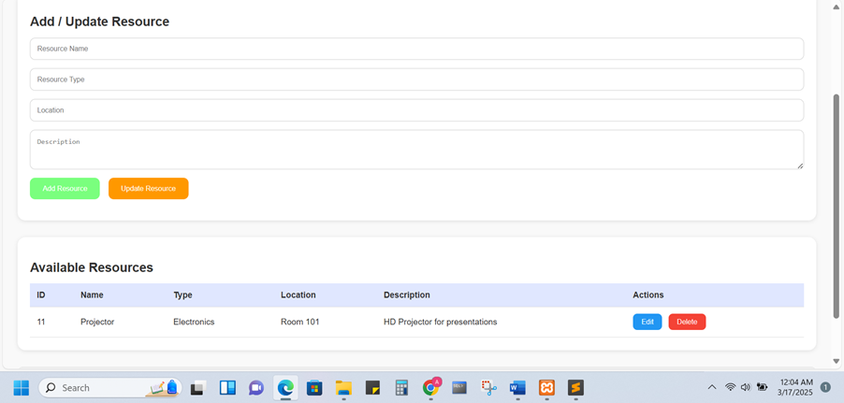

Test 10

|  |  |
| --- | --- |
| Project Name: Smart Campus Management System | |
| Date created and Executed: 16/03/2025 | |
| Created and executed by - Fathima Nuzrath Nawfer | |
| Module: Delete resources from Resource Management | |
| Test case ID | 10 |
| Test Scenario | Delete resources from the system |
| Test case | Delete the resources |
| Pre-condition | Need the web application and Test Data |
| Test Steps | 1.Login  2.Go to the resource management page  3. Click on the delete option |
| Test Data | Delete Resource information  Name: Conference table  Type: Furniture  Location: Meeting Room  Description:      Seats up to 10 people |
| Expected Result | Already available resources will be deleted |
| Post Condition | We will be able go to the other pages. |
| Actual Result | Data will be displayed successfully after deletion. |
| Status | Pass |

Before deleting the resources

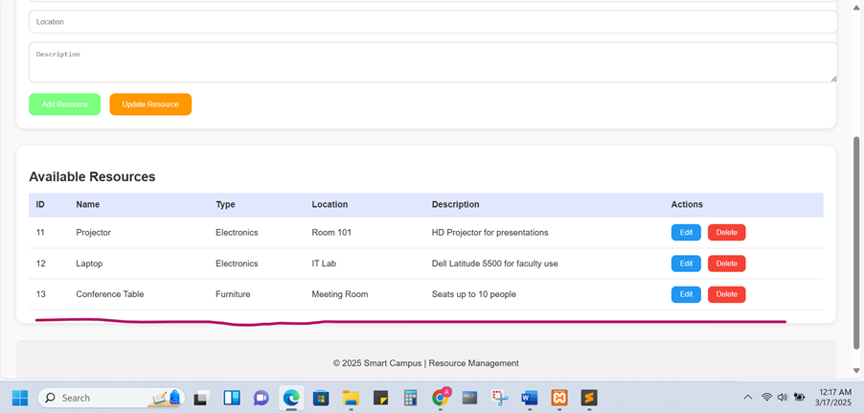

After deleting the resources

Test 11

|  |  |
| --- | --- |
| Project Name: Smart Campus Management System | |
| Date created and Executed: 16/03/2025 | |
| Created and executed by - Fathima Nuzrath Nawfer | |
| Module: Update resources from Resource Management | |
| Test case ID | 11 |
| Test Scenario | Delete resources from the system |
| Test case | Delete the resources |
| Pre-condition | Need the web application and Test Data |
| Test Steps | 1.Login  2.Go to the resource management page  3.Go to the edit button displayed in the bottom  4.Click on Update |
| Test Data | Resource informations  Name: Microphone  Type: Electronics  Location: Auditorium  Description:       |  | | --- | | Wireless microphone for speeches | | Change the location to **“Room 110”** |   From Auditorium |
| Expected Result | Updated data will be displayed in the Resource Management interface |
| Post Condition | We will be able go to the other pages. |
| Actual Result | Updated data will be displayed successfully |
| Status | Pass |

Before the update

After the update

Test cases for Registration

|  |  |
| --- | --- |
| Project Name: | Smart campus Management system |
| Date created and Executed: | 17/03/2025 |
| Created and Executed By: | Fathima Nuzrath Nawfer |
| Test case ID | 12 |
| Test scenario | Register a new user to the system |
| Test Case | Valid credentials |
| Pre-Condition | Use a unique email address and username with proper password which has more than 8 characters |
| Expected result | Successful registration |
| Post condition | It will say successfully registered |
| Actual result |  |
| Status  (success  /Failure) | Success |

|  |  |
| --- | --- |
| Project Name: | Smart campus Management system |
| Date created and Executed: | 17/03/2025 |
| Created and Executed By: | Fathima Nuzrath Nawfer |
| Test case ID | 13 |
| Test scenario | Register a new user to the system |
| Test Case | Password criteria didn’t meet |
| Pre-Condition | Use a short password and without using any special characters or not using numbers |
| Expected result | Error message pop up |
| Post condition | It will say password must be at least 8 characters long and include one uppercase letter, one lowercase letter, one number and one special character |
| Actual result |  |
| Status  (success  /Failure) | Success |

|  |  |
| --- | --- |
| Project Name: | Smart campus Management system |
| Date created and Executed: | 17/03/2025 |
| Created and Executed By: | Fathima Nuzrath Nawfer |
| Test case ID | 14 |
| Test scenario | Register a new user to the system |
| Test Case | If you register with existing username or email |
| Pre-Condition | Register with existing username or email |
| Expected result | Error message pop up |
| Post condition | It will say Username or Email already exists! |
| Actual result |  |
| Status  (success  /Failure) | Success |

|  |  |
| --- | --- |
| Project Name: | Smart campus Management system |
| Date created and Executed: | 17/03/2025 |
| Created and Executed By: | Fathima Nuzrath Nawfer |
| Test case ID | 15 |
| Test scenario | Register a new user to the system |
| Test Case | If you miss to fill any field |
| Pre-Condition | Register without filling all the fields |
| Expected result | A reminder to fill the fields |
| Post condition | It says please fill this field |
| Actual result |  |
| Status  (success  /Failure) | Success |

|  |  |
| --- | --- |
| Project Name: | Smart campus Management system |
| Date created and Executed: | 17/03/2025 |
| Created and Executed By: | Fathima Nuzrath Nawfer |
| Test case ID | 16 |
| Test scenario | Register a new user to the system |
| Test Case | If you enter two different passwords. |
| Pre-Condition | Register by entering two different passwords |
| Expected result | An error message appears |
| Post condition | It says Passwords do not match! |
| Actual result |  |
| Status  (success  /Failure) | Success |

|  |  |
| --- | --- |
| Project Name: | Smart campus Management system |
| Date created and Executed: | 17/03/2025 |
| Created and Executed By: | Fathima Nuzrath Nawfer |
| Test case ID | 17 |
| Test scenario | Register a new user to the system |
| Test Case | Enter an invalid email format |
| Pre-Condition | Register by entering an invalid email format |
| Expected result | An error message appears |
| Post condition | It says Invalid email format! |
| Actual result |  |
| Status  (success  /Failure) | Success |

**5.2 Acceptance Testing**

**Feedback Form**